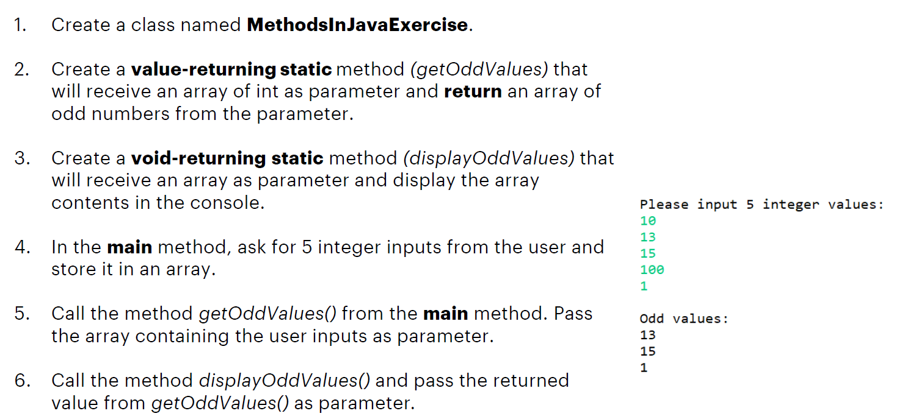

**Note:** You can also try to change steps 2 and 3 to instance methods and then try to call these methods to be able to see the difference between static and instance methods.